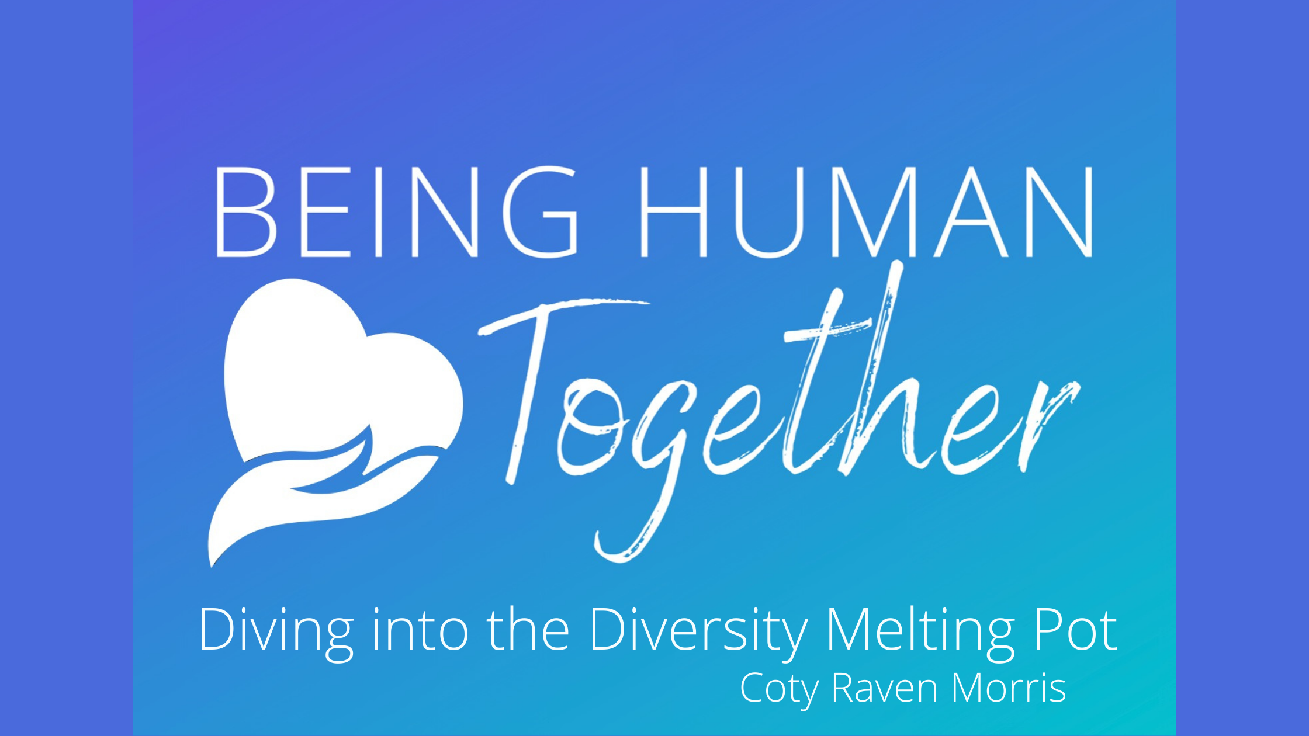
The opposite of love is not hate... It is indifference.

Our study of diversity and inclusion is to bring awareness to differences, showcase beauty and teach history, and bridge the gap with knowledge, acceptance, understanding, and connection.

Find more resources at www.cotyravenmorris.com

What is your accountability moment for the day?

What is your ethnicity, culture, and race?
Ethnicity
Culture (s)
Race

What are your privileges?

Lean into the Dissonance
How to Have These Conversations
Content vs. Context (feelings and investments go here)
Many of us have been conditioned by society to not speak our minds, and so we haven’t acquired the skills of navigating difficult conversations. Without practice in something, confidence lacks, and fear often sets in. So let’s practice!
In the end, we’re worried about our identity and self-preservation. In order to make these conversations less difficult and more effective, let’s step outside of ourselves and focus on the other person. That starts with empathy:
- Start from a place of humility
- Approach the conversation with an interest in problem-solving, instead of needing to be “right”
- Focus on what you’re hearing, not what you’re saying
- Expect a positive result
Culturally Responsive Teaching (CRT): A pedagogy of opposition not unlike critical pedagogy but specifically committed to collective, not merely individual, empowerment. Culturally relevant pedagogy rests on three criteria or propositions: (a) Students must experience academic success; (b) students must develop and/or maintain cultural competence; and (c) students must develop a critical consciousness through which they challenge the status quo of the current social order.
CRT in the Choral Classroom | Conflict resolution in CRT takes:
- Know the Students  - Build on Student Strengths  - Connect Home and School Experiences  - Use a Wide Variety of Musics  - Present Music in its Social and Political Context  - Acknowledge and Share Multiple Perspectives  - Encourage a Sense of Community with High Expectations for All | 1. Listening  2. Being color-cognizant rather than color-blind  3. Responding non-defensively  4. Being open to learning  5. Self-reflecting about how personal and social identities can influence these interactions

“The primary goal in performing multicultural music should be an enhanced understanding that encompasses the character of the culture and accurately represents the music itself.” — Clayton Parr

Eight simple rules for performing and practicing music of the world’s traditions
Connect with Culture | Focus on a limited number of Styles
Listen Widely, Deeply and Repeatedly | Provide the Context
Leave Your Comfort Zone | Seek Authentic Sources
Learn the Language | Teach Authentically

What Now? How to Take Action
- Have CONTINUED conversations (colleagues, students, peers)
- Normalize the conversation
- Bring these resources to your classroom!
- Don’t let fear and power drive your classroom.
- Perform in honor of Black History Month, Hispanic Heritage Month, and other cultures
- Spice up that composer wall
- Celebrate the birthdays of other prolific composers of color
- Language is essential to progress: by changing your mind, you also change your heart.
- You don’t have to be afraid, or fight, or have a degree in these studies… but you have to do SOMETHING.

Notes:

