When all the music elements combine, we get ….

The Five “T”s!

It gives us the opportunity to understand the music before we even sing a note!
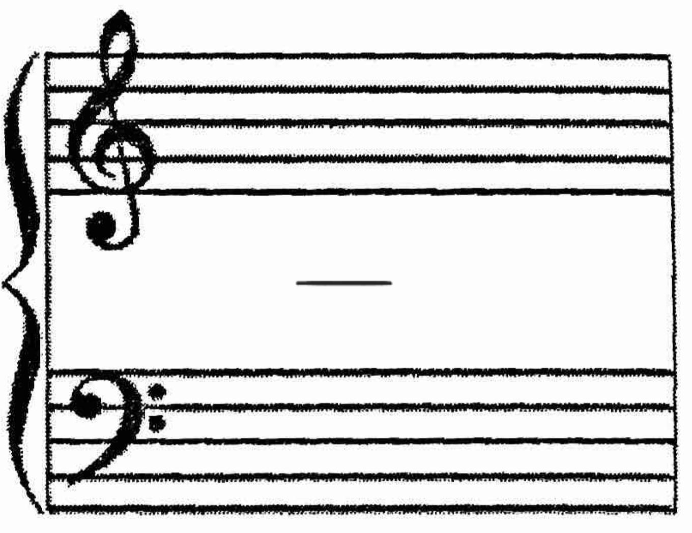
Tessitura (What is the range of your voice part? Of other voice parts?)

Text (Language, Origin of text, Poet, Form, your interpretation, etc):

Time (tempo, time signature, time period)

Tonality (Key, Accidentals? Hint to modulation? Where”):

Texture (How many parts are performing? Instruments?):

Your director may invite you to share other thoughts about this piece. Feel free to do so here!

